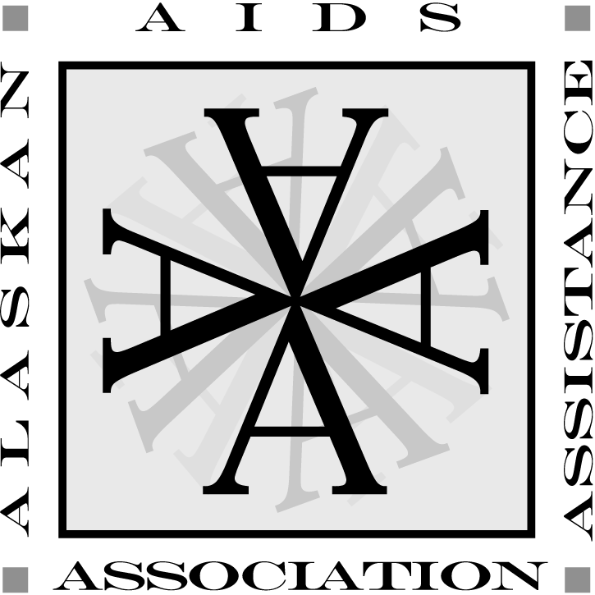 | JOB DESCRIPTION

POSITION TITLE: HIV Prevention and Education LGBTQ Specialist – Anchorage/Mat-Su

REPORTS TO: Director of HIV Prevention and Education

STATUS: Non-exempt, Part-time 10 hours/week The HIV Prevention and Education LGBTQ Specialist provides HIV prevention and education services in Anchorage and Mat-Su. The primary focus of the HIV Prevention and Education LGBTQ Specialist is to conduct interventions to reduce the transmission of HIV and its stigma with an emphasis on the LGBTQ community. HIV prevention and education efforts will involve collaborating with local LGBTQ organizations and other related social service entities to raise awareness of HIV, conducting outreach and education workshops, providing free HIV and Hepatitis C (HCV) rapid testing at a variety of venues, the distribution of condoms, lube, and safe sex kits, and education on PrEP (preexposure prophylaxis). These services will be provided in a in a variety of settings during the day, evening, and weekends.

This position is funded through the Pride Foundation for 1 year. There may be the possibility to extend the position beyond that time frame.

JOB SUMMARY
The HIV Prevention and Education LGBTQ Specialist provides HIV prevention and education services in Anchorage and Mat-Su. The primary focus of the HIV Prevention and Education LGBTQ Specialist is to conduct interventions to reduce the transmission of HIV and its stigma with an emphasis on the LGBTQ community. HIV prevention and education efforts will involve collaborating with local LGBTQ organizations and other related social service entities to raise awareness of HIV, conducting outreach and education workshops, providing free HIV and Hepatitis C (HCV) rapid testing at a variety of venues, the distribution of condoms, lube, and safe sex kits, and education on PrEP (preexposure prophylaxis). These services will be provided in a in a variety of settings during the day, evening, and weekends.

This position is funded through the Pride Foundation for 1 year. There may be the possibility to extend the position beyond that time frame.

QUALIFICATIONS
Education and Experience: Prefer a background/experience in health education, social services, or related field. Past experience working with people who are at risk for HIV/AIDS, Hepatitis C, substance abuse, and/or addiction is a plus.

Communication Skills: Communicate effectively in oral and written form with clients, family members, agency staff, other service agencies, and the general public; as well, strong active listening skills.

Equipment:
- Ability to operate proficiently a personal computer, fax machine, printer, and copier.
- Access to reliable transportation.

Physical Requirements:
- Frequent communication - verbal and written.
- Frequent sitting and/or standing.
- Repetitive movement of hands and fingers - typing and/or writing.
- Visually or otherwise identify, observe and assess.
- Occasional stooping, kneeling or crouching.
- Reach with hands and arms.
- Use math/calculations.
- Lifting Requirement – minimum of 25 lbs.
- At least 21 years old
Certifications and Clearances: Valid driver's license; proof of auto insurance (if using private vehicle). Federal and State background check and TB test.

Knowledge: Must be knowledgeable about HIV/AIDS prevention. Must be comfortable discussing sexual health and drug use with a wide range of persons in a variety of settings. Must be skilled in group facilitation, community organizing, and a thorough understanding of community resources.

Access to PHI: Will have access to Protected Health Information as outlined in Four A’s Privacy Polices & Procedures.

Essential Job Functions:
- Provide services in accordance to the Four A’s mission statement.
- Responsible for adhering to all policy and procedures as outlined in the Employee Handbook and other departmental procedure manuals.
- Ensure services meet all requirements as outlined by the funding source and/or State or Federal law.
- Be available to perform scheduled outreach activities during the day, evenings, and weekends.
- Conduct rapid HIV testing and education through outreach in a variety of settings including at LGBTQ organizations including Identity, Inc., Mad Myrna’s, The Raven, Chilkoot Charlies, and at special events including PrideFest, HIV/AIDS Awareness Days, National HIV Testing Day, and at the Four A’s office.
- Collect, track, and input data related to HIV/HCV rapid testing.
- Distribute condoms and safe sex kits to local bars and agencies.
- Attend monthly Four A’s staff meetings and other specified meetings/trainings as required.
- Attend and facilitate collaborative meetings with community partners to coordinate outreach events.
- Accurately complete job assignments, agency forms, and written documents within assigned deadlines.
- Communicate effectively in oral and written forms with consumers, significant others, coworkers, supervisors, other service agencies, and the community.

Non-Essential Job Functions
This Job Description does not list all your job duties. Occasionally your supervisor might request that you perform other reasonable duties. Review of your performance is based on your performance of the duties listed in this Job Description and these other duties. The Four A’s reserves the right to revise this Job Description at any time. This Job Description is not a contract for employment. Therefore, either you or the Four A’s may terminate the employment relationship at any time, for any reason, with or without notice, with or without cause.

_________________________________ __________________________
Employee Signature Date

